**MEMO**

**TO:** Dr. Michel E Whittenberg

**TEAM:** 14

**SUBJECT:** DELIVERABLE 4

**Scope:**

The objective of this project is to build a well-defined, highly precise, and cost effective computer controlled conveyor belt system for future installations. The newly developed conveyor system is expected to replace the existing system and be flexible enough to incorporate any future technical advancements.

Monthly Cash Flow and the Project Budget Report are attached as appendices below.

1. The project will cost $1,208,304
2. Following are our observations of the cash distribution in the cash flow statement:

* We observed that costs are allocated sequentially and follows the critical path. The first cost is allocated to the first activity in the critical path and the followed by the rest.
* The highest cost allocation happens in the 2nd quarter of the 1st year. We also noticed that cost allocations reaches its peak in the beginning of the 1st year and towards the end of 2nd year.
* The highest cost is allocated for disk drivers.

**Appendix A**

**MONTHLY CASH FLOW**

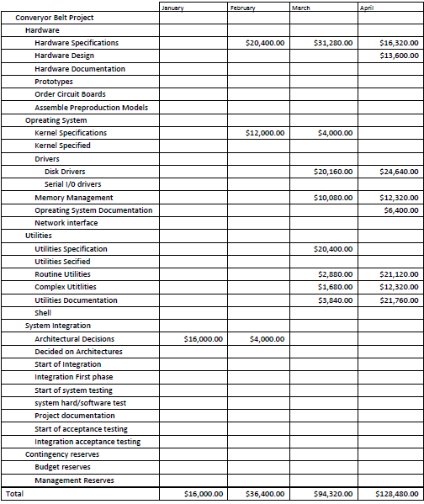

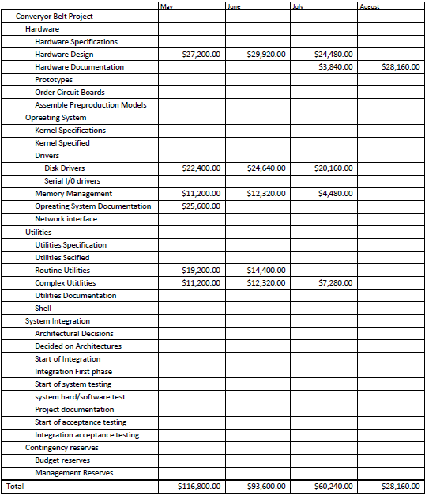

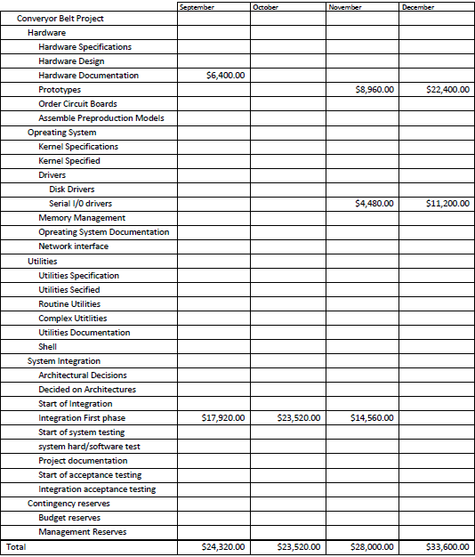

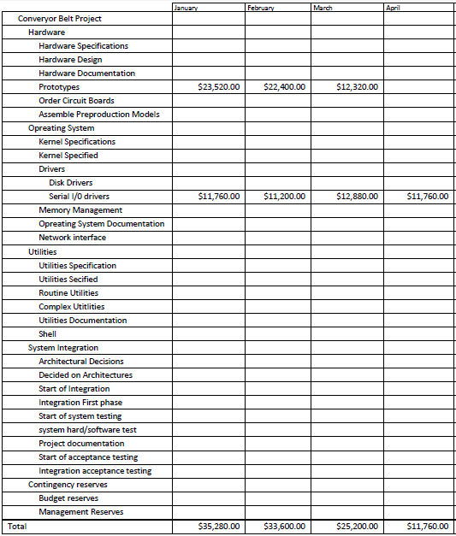

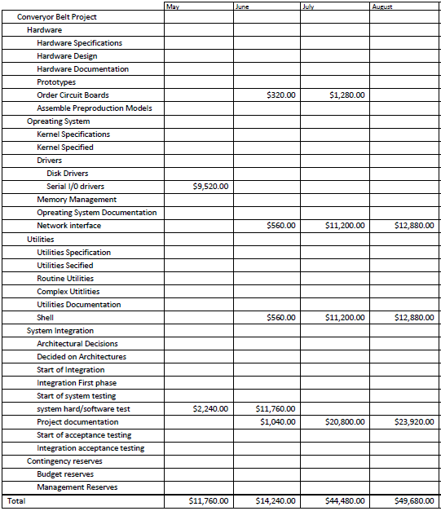

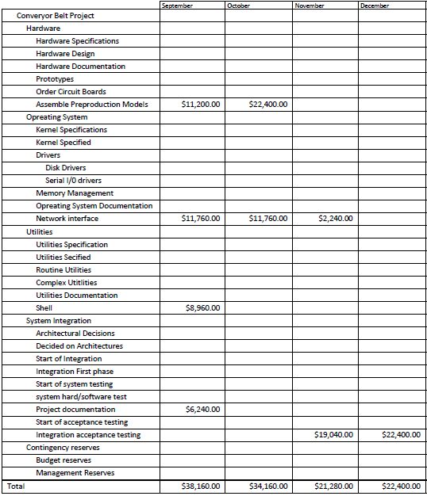

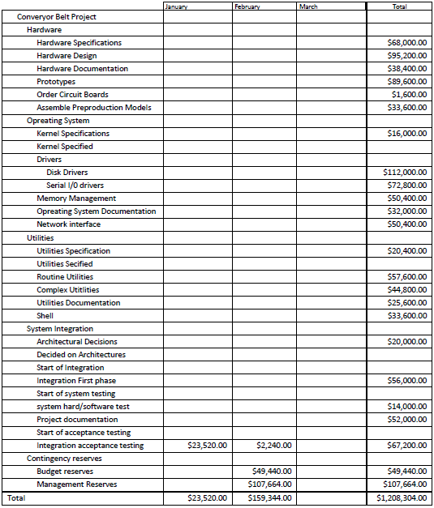

**Appendix B**

**PROJECT BUDGET REPORT**

